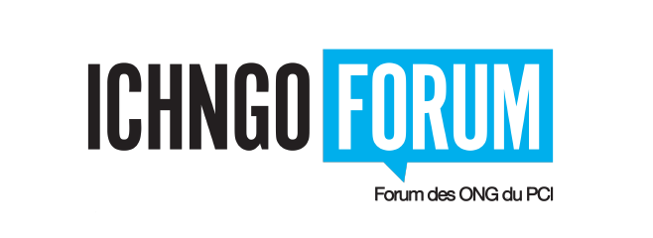
2022 Elections – Steering Committee
Application Form

Please return this form at the latest by October 25th, 2022 (midnight, Western European Time, WET, UTC+1) to the Electoral Board, duly completed, signed and dated, along with a curriculum vitae of one to two pages, to all members of the Electoral Board:
Adel Moussa, Nubian Heritage Society (Arab States)
Diana Teresa Gutiérrez, Embodying Reconciliation (Latin America and Caribbean)
Sandrine Moughola, ADACO (Africa)
adelmosa73@gmail.com
diana.embodying@gmail.com
pouatydav@yahoo.fr; sandrine.sanda@yahoo.com

Electoral region of the candidate
- Western Europe and North America (two-year term)
- Asia-Pacific (two-year term)
Candidate for an International ONG
- International NGO (two-year term)

NGO, with its headquarters located in the region:
Name:
Headquarters in (country):
Accreditation date / renewal:
E-mail:

The candidate
oMr oMs oOther
First Name:
Family Name:
E-mail:

Desired profile
 | Yes | No | Comments
Be member of an accredited NGO under the 2003 Convention
Have participated at a minimum of two sessions of the Governing bodies of the 2003 Convention
Have a good working knowledge of English and/or French, both oral and written
Have access to a good internet connection
Have a reasonable knowledge and be well connected to ICH NGOs, accredited or not, in his region
Be willing to draft and review documents related to the communication tasks of the Committee
Be willing to moderate sessions of the Forum
Be willing to undertake activities of representation for the Committee and for the Forum
Have received the approval of the NGO to become member of the Steering Committee

Signature of Candidate
Name:
Position in the NGO:
Date:
Seal of the NGO:

One paragraph on Objective/Agenda/Statement of Purpose for applying.

Add a one or two page curriculum vitae outlining ICH related experiences

(If no alternate candidate, please go to the end of the application form for the signature of the person authorized to sign and the seal of the NGO)
The alternate candidate
oMr oMs oOther
First Name:
Family Name:
E-mail:
Desired profile
 | Yes | No | Comments
Be member of an accredited NGO under the 2003 Convention
Have participated at a minimum of two sessions of the Governing bodies of the 2003 Convention
Have a good working knowledge of English and/or French, both oral and written
Have access to a good internet connection
Have a reasonable knowledge and be well connected to ICH NGOs, accredited or not, in his region
Be willing to draft and review documents related to the communication tasks of the Committee
Be willing to moderate sessions of the Forum
Be willing to undertake activities of representation for the Committee and for the Forum
Have received the approval of the NGO to become member of the Steering Committee
Signature of Alternate Candidate

Signature of the person responsible for the NGO or other authorized person:

Name:
Position in the NGO:
Date:
Seal of the NGO:
4

